Low-Level Design (LLD)
Cloud-Based File Sharing Portal
Project: Cloud-Based File Sharing Portal
Version: 1.0
Date: 24-Oct-2025
Author: Emad’s Super Cloud Squad
[Year]
Contents
1. Introduction 1
2. Design Scope 2
In Scope: 2
Out of Scope: 2
3. Key Requirements (Summary) 2
4. High-Level Architecture (Diagram + Narrative) 3
High-Level diagram 3
Main components (explanations): 3
5. Component Interaction (Flow) — File Upload Scenario 4
6. Azure Services Mapping (Component → Suggested Azure Service) 4
7. Non-Functional Requirements (NFRs) 5
8. Security Considerations 5
9. Backup and Disaster Recovery (Backup & DR) 6
10. Performance and Cost Considerations 6
11. Acceptance Criteria (Success Criteria) 6
12. Assumptions and Limitations 7
Assumptions: 7
Limitations: 7
13. Items for Detailed Design (LDD Pointers) 7
14. Appendices 7

1. Introduction
A short description of the document purpose:
This document describes the high-level design for the Cloud-Based File Sharing Portal. It identifies the main components, their interactions, Azure service mapping, and key non-functional requirements.

2. Design Scope

In Scope:
- Web and mobile responsive user interfaces
- Authentication via Azure AD and B2B for external users
- Encrypted file storage on Azure Blob Storage
- Background processing via serverless (Functions) plus a queue
- Metadata and session caching using Azure Cache for Redis
- Logging, monitoring, and audit via Azure Monitor and Log Analytics

Out of Scope:
- Advanced real-time document co-editing
- Using on-premises storage as the primary store

3. Key Requirements (Summary)
- Support file uploads up to 500 MB.
- Role-based access control (RBAC).
- Encryption of data in transit and at rest.
- Retain audit logs for 7 years.
- Target availability 99.95% for core services.

4. High-Level Architecture (Diagram + Narrative)

High-Level diagram
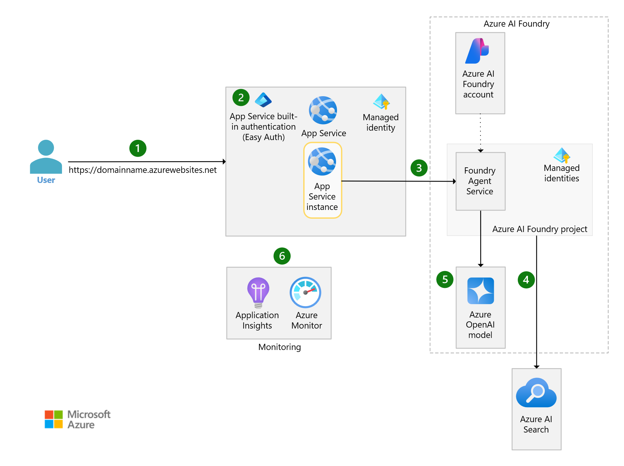

Main components (explanations):
- Front Door / CDN: Global entry point for traffic distribution, DDoS protection, and WAF.
- Web App / SPA: User interface (React/Angular) hosted on Static Web Apps or App Service.
- API Gateway (Azure API Management): Unified API layer with policies, rate limiting, and logging.
- Authentication: Azure AD plus Azure AD B2B or Azure AD B2C for external/guest users.
- Business Logic: Serverless functions (Azure Functions) or App Services for sync/async tasks.
- Queue: Azure Service Bus or Storage Queue to buffer background tasks (e.g., file processing).
- Storage: Azure Blob Storage with tiering: hot for active files, cool/archive for long-term retention.
- Cache: Azure Cache for Redis to accelerate metadata and session reads.
- Monitoring & Logs: Azure Monitor, Log Analytics, Application Insights.
- Security & Compliance: Azure Key Vault for secrets, encryption at rest/in transit, optional DLP/MIP.

5. Component Interaction (Flow) — File Upload Scenario
- User authenticates via Azure AD.
- User initiates upload on the UI; the UI requests a signed upload URL or uploads via API.
- API accepts the upload and enqueues an UploadJob message to the queue.
- A background worker consumes the message, performs virus scanning, generates thumbnails, stores the file in Blob Storage, and updates metadata in the database.
- Cache is refreshed to provide fast search and retrieval.
- All steps are logged and audited to Log Analytics and long-term storage for compliance.

Azure Services Mapping (Component → Suggested Azure Service)

Function | Suggested Azure Service
Edge + WAF | Azure Front Door + WAF
CDN | Azure CDN
Static Web / SPA | Azure Static Web Apps / App Service
API Gateway | Azure API Management
Authentication | Azure AD, Azure AD B2C (if needed)
Serverless | Azure Functions
Queue | Azure Service Bus
Object Storage | Azure Blob Storage (General Purpose v2)
Cache | Azure Cache for Redis
Metadata DB | Azure SQL / Cosmos DB (choose by data model)
Key Management | Azure Key Vault
Monitoring | Azure Monitor, Application Insights, Log Analytics
Backup / Archive | Blob Lifecycle + Archive Tier
Security | Azure Policy, Defender, Sentinel (optional)

7. Non-Functional Requirements (NFRs)
- Performance: API latency ≤ 300 ms for normal requests. Large file upload availability depends on network but processing end-to-end ≤ 2 minutes for typical sizes.
- Availability: 99.95% for critical services.
- Scalability: Horizontal scaling via App Service scaling rules or Functions Consumption/Premium plan.
- Resiliency: Retries and dead-letter handling for failed messages.
- Security: AES-256 encryption at rest, TLS 1.2+ in transit, MFA for sensitive actions.
- Compliance: Audit logs retained 7 years. Support for GDPR/ISO reporting if required.

8. Security Considerations
- Use Managed Identities for service-to-service access instead of storing secrets.
- Store secrets and certificates in Azure Key Vault with strict access policies.
- Apply RBAC and least privilege for users and service principals.
- Enable WAF rules, rate limiting, and DDoS Protection Standard.
- Perform security scans and penetration testing prior to production cutover.
- Ensure backups are encrypted and access-controlled.

9. Backup and Disaster Recovery (Backup & DR)
- Regular snapshots for Blob storage and metadata DB backups.
- Lifecycle policies to move files to Cool and Archive tiers after defined retention periods.
- DR plan with alternative region failover via Front Door when required.
- Target RTO < 4 hours and RPO < 1 hour for critical services.

10. Performance and Cost Considerations
- Use caching to reduce load on metadata DB.
- Apply storage tiering to control long-term costs.
- Choose Functions Consumption plan to pay-per-use, or Premium plan if VNet integration and predictable performance are required.
- Set autoscale rules for App Services and monitor to avoid cost spikes.

11. Acceptance Criteria (Success Criteria)
- Uploading a 500 MB file succeeds and is accessible to the user within ≤ 2 minutes.
- Authentication works for Azure AD and guest users.
- Audit logs are available, exportable, and retained for 7 years.
- System load test: sustain 10,000 concurrent requests with acceptable error rate.
- Security scan reports no critical vulnerabilities before go-live.

12. Assumptions and Limitations

Assumptions:
- Azure subscriptions and required budgets are available.
- Network connectivity between Azure services is permitted per NSG and firewall rules.

Limitations:
- Files larger than 500 MB require chunked upload handling and additional design.
- Relying on PaaS services imposes constraints on low-level network control.

13. Items for Detailed Design (LDD Pointers)
- Database schema design and ER diagrams.
- REST API specification (endpoints, payloads, auth flows).
- Sequence diagrams for key scenarios.
- Terraform/ARM templates for infrastructure deployment.
- CI/CD pipelines using GitHub Actions or Azure DevOps.

14. Appendices
- Glossary (RBAC, RTO, RPO, SLA, etc.)
- Security checklist
- References and links to detailed design documents

